Gulgong Chamber of Commerce

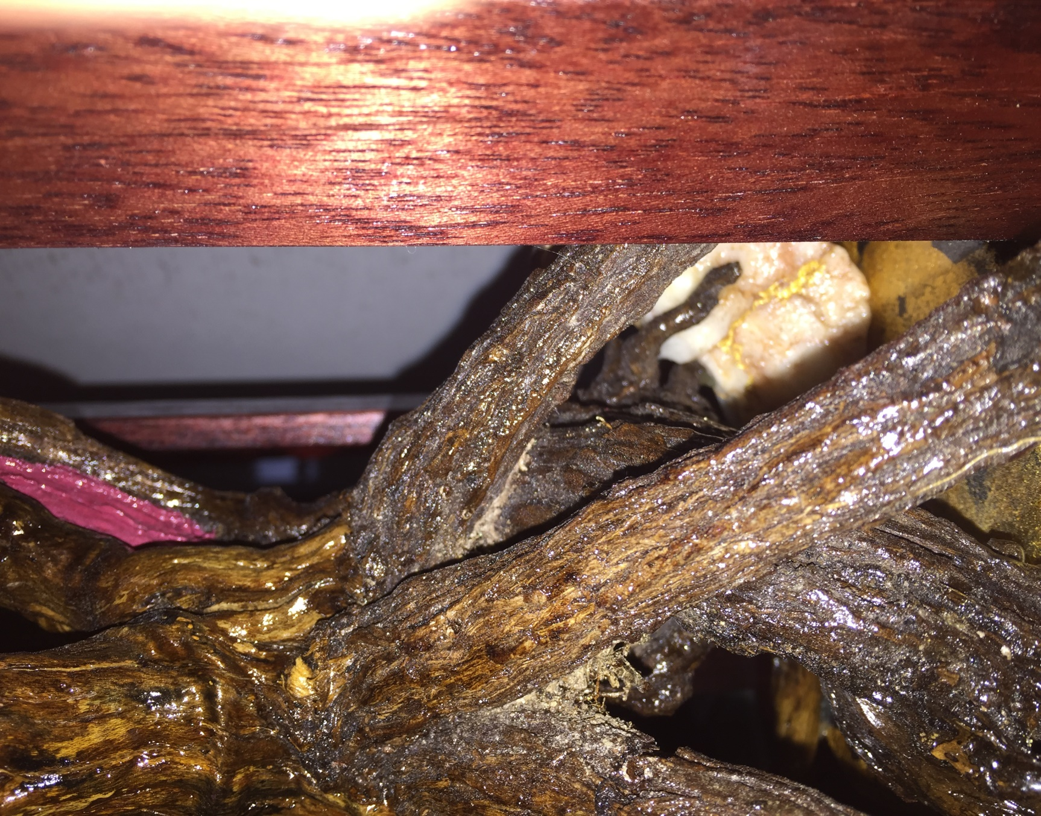

SELWYN
MEMORIAL TROPHY

GULGONG ANNUAL Gold and mining
FOR BEST WINDOW DISPLAY

Gulgong Chamber of Commerce

SELWYN MEMORIAL TROPHY
GULGONG ANNUAL gold and mining festival
FOR BEST WINDOW DISPLAY
The Selwyn Memorial Trophy is awarded annually for the best Gulgong and surrounding district shop front display. The window display pays tribute to the significant contribution made by miners during the Gulgong gold rush and the legends and stories of the Gold Fields. Miners came from many nations, but Gulgong retains a significant slice of the history from the Chinese miners and traders. Whilst the trophy is based on Chinese culture, it represents key elements of the local area and celebrates all nations who made Gulgong what it is today.
Naming the trophy honours the community service and contribution to sport, agriculture and local government by the late Leo Selwyn.
For further information on how to enter the competition, see the Gulgong Chamber of Commerce website http://www.gulgong.com.au or contact the Chamber secretary secretary@gulgong.com.au
The trophy is representative of aspects of Chinese culture and symbolism and in particular “The five Elements”:

It is eight sided. Eight is an infinity symbol on its side and represents prosperity. The cap and base hold the land within it. Trees are representative of all aspects of life and connect the ground to the sky. The five risers mirror the five elements of the universe. The Theory of the Five Elements - Wu Xing (Chinese: 五行; pinyin: wǔxíng), often shortened to Five Elements, is the concept in Chinese philosophy conceiving the world as dynamic states, or phases, of constant change. The quartz is the same rock that was mined and crushed to get the gold. It sits on an eight sided representation of earth. The five green ribbons represent the leaves and are at the mercy of the wind.

The colours are red, black, yellow (gold), green and white of the quartz. These are the five principle colours of the five elements.

Red is the traditional bridal colour and represents joy, celebration, happiness, prosperity, money and a long life.

Black for boys continues the lineage of the family. It has the properties of immortality, trust, knowledge and adaptability, spontaneity, career and will.

Green is growing, generating, sprouting, striving, refreshing, balancing, calming, healing, self-assurance, foundation, benevolence, health, harmony and sensitivity. It is the fragility of the natural world but like black has elements of continuing.

White is death and ancestral spirits. It is mourning, withering, righteousness, courage and sadness.

Gold is god consciousness, wealth and completeness. It is the metal that represents yellow, a colour reserved for royalty.

Throughout the years, and even today, colours are very important to the existence of the Chinese people.
Today:
1. Yellow is still reserved for royalty. Clothing and objects that are yellow in colour still resemble a higher social status. Although each dynasty designated each official rank with their own colour, yellow is reserved or the emperor himself.
The colour yellow and its shades are also the main colour of Buddhism; thus it represents being free from worldly cares.
2. Red is still used for happiness and joy. In fact, after the Ming Dynasty, only the Emperor's close relatives could have homes with red walls and yellow roof tiles. Peasants could only live in homes made with blue bricks and roof tiles. Today though, most houses are made of black tiles and white walls.
3. Blue-green is still a symbol of spring when everything is filled with vigour and vitality. Therefore, someone that is hoping for longevity and harmony will decorate with blue-green colours.
4. White is a symbol of the unknown and purity. The colour white is used during the time of mourning, death, and during ghost festivals.
Therefore Chinese people will wear white during a funeral or while summoning ghosts.
5. Black is used as the symbol of winter and the westerly skies which behold the heavens. It is used for times of the unknown and for the winter months.

The trophy base is surmounted by a gold plate mounted on a silver pedestal. There are two dragons facing inwards sitting at the east and west.

A pair of dragons represents eternity, yin and yang. It is one of the twelve symbols of sovereignty and the only non-earthly creature.

Silver represents wealth and income. It is also trustworthiness and romance. As a metal it can represent white

The round plate is used for serving sweets and fruits. Eight elements are served on the plate because it is a symbol of fortune. The circle represents togetherness. So, the plate is about family and community. It was originally a wedding present to Jan and Kevin Robson who have contributed to Gulgong’s community over a number of years. The plate was restored prior to mounting and is plated in 24 ct gold. The plate is a true representation of family.

The Trophy Case has been designed, constructed and donated by Mark Cummings of Gulgong Glass and Glazing. It is constructed of four pieces of perspex representing glass and wood. The Glass represents the cardinal points as well as sky. The wooden base represents earth.

- Prepared: Paul Fookes 2016 Authorised: W.(Bill) Murphy,
- Revised: Paul Fookes 2017 President
Gulgong Chamber of Commerce
Dec 2017

The original name for the festival was the Chinese Gold Festival but organisers felt that to single one group out of what was a United Nations of people seeking their fortunes on the Gulgong Gold Fields and ignore the mining aspect was limiting. The re-named trophy pays homage to the history of Gulgong and the people who forged the history but uses the Chinese heritage as a symbol of all those who won and lost, whether as miners, traders or story tellers. Gulgong is “more than just history”. It is the people and the legacy upon which we all now stand.

Wood, Fire, Earth, Metal and Water. Taoist theory has been refined over years and is not only representative of the actual element but of emotions and actions of a “Dynamic State” Further reading: http://www.nationsonline.org/oneworld/Chinese_Customs/five_elements.htm
http://www.nationsonline.org/oneworld/Chinese_Customs/five_elements.htm
http://www.nationsonline.org/oneworld/Chinese_Customs/colours.htm
Direct text from http://www.nationsonline.org/oneworld/Chinese_Customs/colours.htm
http://www.nationsonline.org/oneworld/Chinese_Customs/food_symbolism.htm

